**ASSIGNMENT 8.1**

1. Write a mapreduce program to find the total amount of petrol in volume sold by every distributor.

Driver Class :

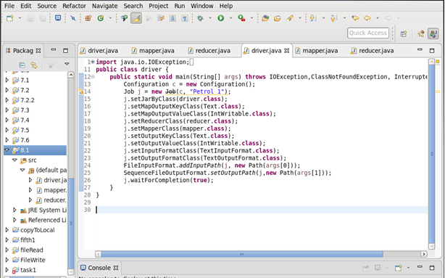

Mapper Class : 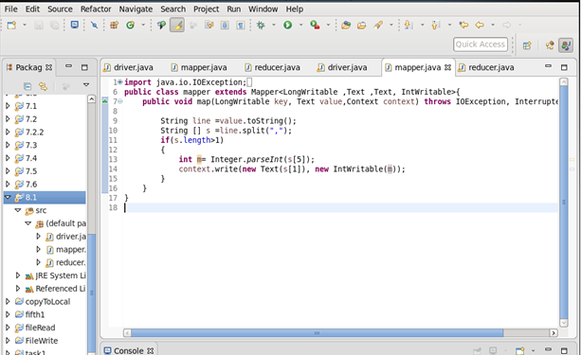

Reducer Class : 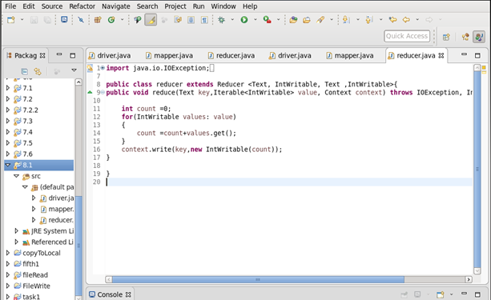

Output : 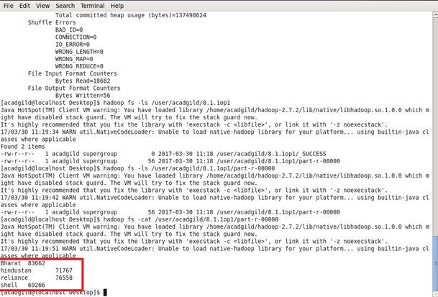

2. Write a mapreduce program to find which are the top 10 distributors ID's for selling petrol and also display the amount of petrol sold in volume.

Composite Class :

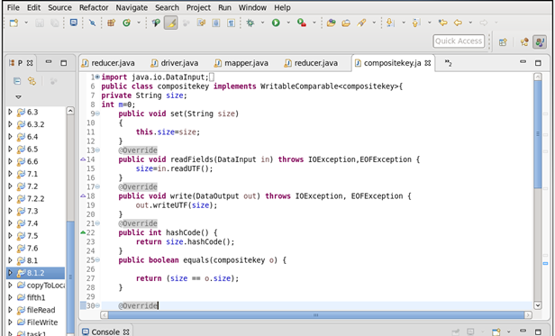

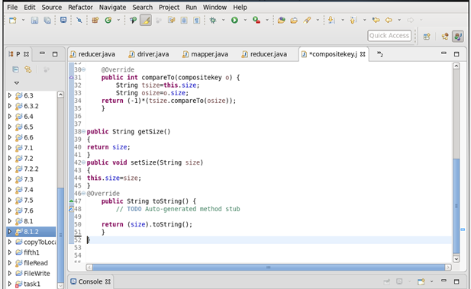

Driver Class : 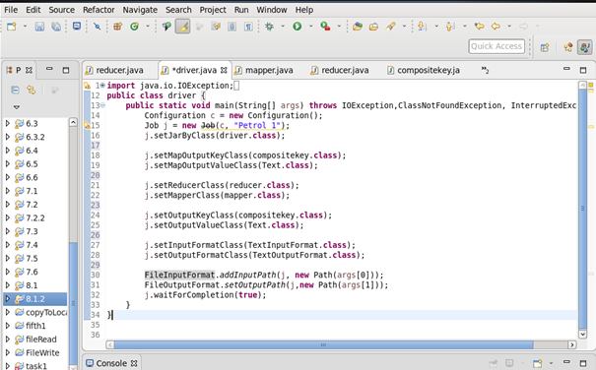

Mapper Class : 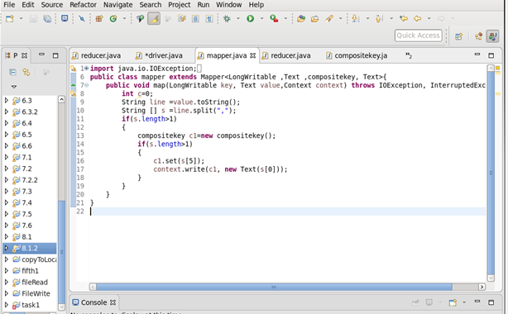

Reducer Class : 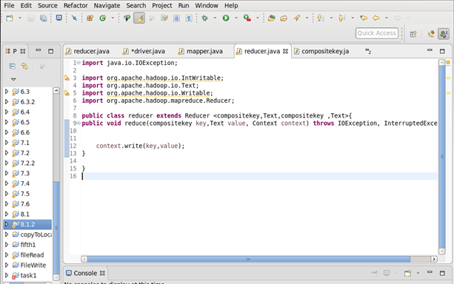

Output : 